Order Of Service

Singing: Psalm 98—CW page 103

Reading: Psalm 119:49-56

Opening Hymn: TLH 657

Reading: Romans 4:1-12

Request Hymn: CW Supplement 750

Reading: Matthew 15:21-31

Sermon Hymn: TLH 39

Sermon Text: Mark 15:6-15

Jesus And Barabbas

Prayer

The Apostles’ Creed, TLH page 12

Holy Communion

The Lord's Prayer

The Blessing

Closing Hymn: TLH 45

* * * * * * * * * * *

Bible Study: Lambs: Pheasant
Sheep: Proverbs 24:21-25
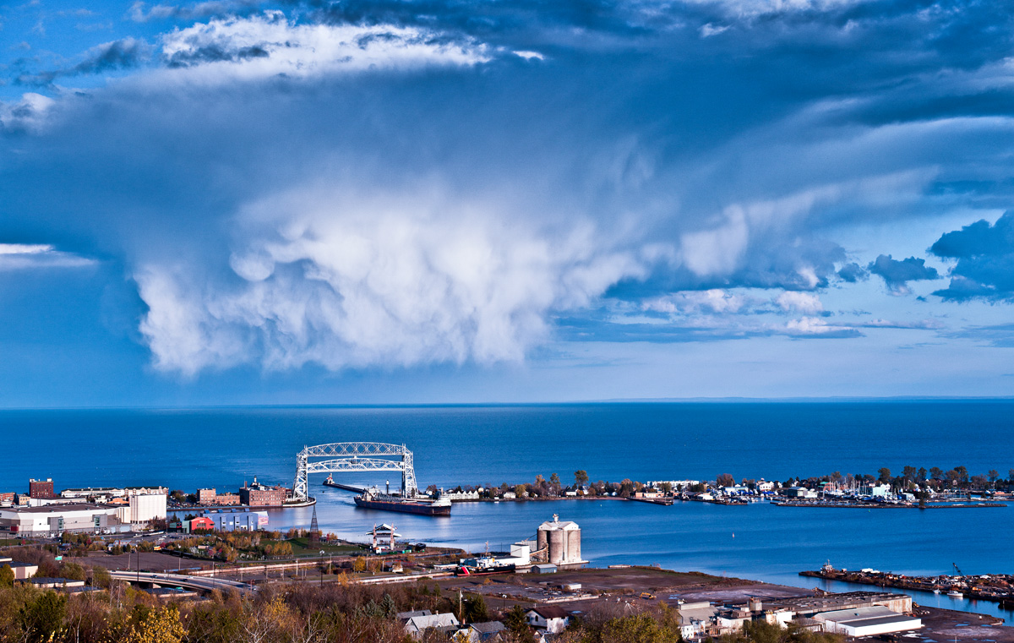

Summer In Duluth, MN

Water
Of
Life

28 June 2020

W A T E R O F L I F E

Independent Christian Church—Conservative Lutheran Doctrine

Worship Service: 9:30 a.m. Bible Study: 10:45 a.m.

Larry Cooper, Pastor E-Mail address:
111 N. Ridge Road lcooper@wateroflife.cc
Coon Valley, WI 54623 Web Site:
www.wateroflife.cc

* * * * * * * * * * * * * * * * * * * * * * * * * * *

Sermon Text: Mark 15:6-15

Jesus And Barabbas

* * * * * * * * * * * * * * * * * * * * * * * * * * *

Mark 15:6 Now at that feast he released unto them one prisoner, whomsoever they desired.
:7 And there was one named Barabbas, which lay bound with them that had made insurrection with him, who had committed murder in the insurrection.
:8 And the multitude crying aloud began to desire him to do as he had ever done unto them.
:9 But Pilate answered them, saying, Will ye that I release unto you the King of the Jews?
:10 For he knew that the chief priests had delivered him for envy.
Mar 15:11 But the chief priests moved the people, that he should rather release Barabbas unto them.
:12 And Pilate answered and said again unto them, What will ye then that I shall do unto him whom ye call the King of the Jews?
:13 And they cried out again, Crucify him.
:14 Then Pilate said unto them, Why, what evil hath he done? And they cried out the more exceedingly, Crucify him.
:15 And so Pilate, willing to content the people, released Barabbas unto them, and delivered Jesus, when he had scourged him, to be crucified.

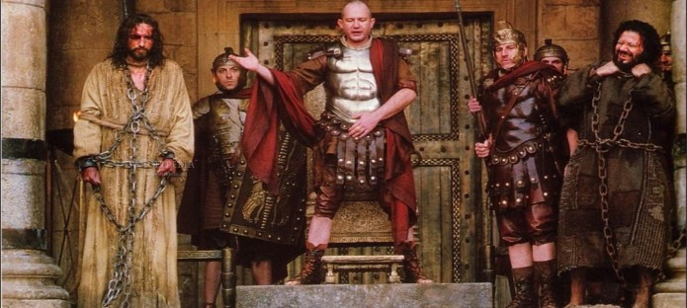

S

